Course ID : BIT 114 Course Name: Discrete Math

Program: BIT Fall 2019

Semester:1Year/1semester




BACHELOR IN INFORMATION TECHNOLOGY

ASSIGNMENT ON

ASSIGNMENT NUMBER:

Submitted by: sunil kumar goley tamang Submitted to: Lincoln University college

Year/ Semester: 1 Year/ I semester

LCID: LC00017000862

Date:06-03-2020

Page | 1
Course ID : BIT 114 Course Name: Discrete Math

Program: BIT Fall 2019

Semester:1Year/1semester

1. Define contradiction and tautology. Show that the compound proposition [p^(p->q)]->q is tautology.

➔ A compound proposition is said to be contradiction if its truth value is always false irrespective to the truth value of its constituent proposition.

For ex:

P | ~P | P^~P
T | F | F
F | T | F

➔ A compound proposition is said to be tautology if its truth value is always true irrespective to the truth value of its constituent proposition. For ex:

P | ~P | Pv~P
T | F | T
F | T | T

➔ Solution:
P | q | p->q | P^(p->q) | [p^(p->q)]->q
T | T | T | T | T
T | F | F | F | T
F | T | T | F | T
F | F | T | F | T

Here, the above table shows that compound proposition [p^(p->q)]->q is tautology.

1. Without expanding show that

1 1 1

a | bc | = (a-b)(b-c)(c-a)

bc ca ab

Page | 2
Course ID : BIT 114 Course Name: Discrete Math

Program: BIT Fall 2019

Semester:1Year/1semester
- Solution:

Given, Taking L.H.S

1 | 1 | 1
a | b | c
bc | ca | ab

First step : R₁->R₁-R₂

1-1 | 1 | 1
a-b | b | c
bc-ca | ca | ab

taking (a-b) common in first row R₁
second step: R₂->R₂-R₁

- 01-11

(a-b) | 1 |  | b-c | c
 | -c | ca-ab |  | ab
Taking (b-c) common in second row R₂
= |  |  |  | 0 | 1
= |  |  | 0 | 0 | 1
(a-b)(b-c) |  |  | 1 | 1 | c
 |  |  | -c | -a | ab
Then,
Here = 1 | 1 | 1
 | -c |  | -a

- 1x-a-(-c)x1

- (c-a)

Hence, we have proved that (a-b)(b-c)(c-a)

L.H.S=R.H.S proved

2. Define homogeneous recurrence relation. Solve the recurrence relation.

Page | 3
Course ID : BIT 114 Course Name: Discrete Math

Program: BIT Fall 2019

Semester:1Year/1semester

a_{n}=6a_{n-1}+8a_{n-2} for n_>2,a₀=4,a₁=10

  - A homogeneous recurrence relation is said to be if the order of k of the form can be found as

an=c1an-1+c2an-2+….+ckan-k

  - Solution:

Given recurrence relation is a_{n}=6a_{n-1}+8a_{n-2}……….(i)

This is the recurrence relation of second order. Its character

equation is ; Or, r²=6r¹-8r⁰ Or, r²-6r+8=0 Or, r(r-4)-2(r-4)=0

Or, (r-4)(r-2)=0 Hence, r₁=2,r₂=4

The solution of eqn(i) is ,
a_{n}= α₁r₁^{n}+α₂r₂^{n}

a_{n}= α₁2^{n}+α₂4^{n}………………….(ii)
Put n=0 in eqn(ii), we get
a₀=α₁2⁰+α₂4⁰

Given a₀=4, then Or, 4=α₁+ α₂ Or, α₂=4-α₁

again, put n=1 Or, a₁=α₁2¹+α₂4¹ Given a₁=10

Or, 10= α₁2+(4-α₁)4 Or, 5=α₁+8-2α₁ Or, α₁=3, α₂=1

Here, the equation is found to be a_{n}=3x2^{n}+1x4^{n}

- Define the term tree, minimum spanning tree, simple, multiple and pseudo graph. Write prim’s and kruskal’s algorithm to construct minimum spanning tree. Explain the process of generating spanning tree using kruskal’s algorithm? Assume example of your own.

  - Tree: A connected undirected graph with no simple circuit is called tree .for a tree a graph must be simple graph.

Page | 4
Course ID : BIT 114 Course Name: Discrete Math

Program: BIT Fall 2019

Semester:1Year/1semester

- Minimum spanning tree: A spanning tree of n connected graph in which the sum of weight of it’s edge in minimal is called minimum spanning tree.

- Simple graph:

- Multiple graph:

- Pseudo graph:

- Prim’s algorithm:

Procedure: G:weighted connected undirected graph with n vertices.

T:= a minimum weight edge. For P:= 1 to n-2.

Begin

e:= an edge of minimum weight incident to a vertex inT and not forming a simple circuit in T if added to T.

T:= T with e added.

End{ T is a minimum spanning tree of G.}

➔

Kruskal’s algorithm:

Procedure:

Kruskal(G: a connected undirected weighted graph with n vertices.)

- = empty graph. For : i: 1 to n-1. Begin

e:= any edge in G with smallest weight and forming a simple circuit if added to T.

T:= tree with e added.

End{T is minimum spanning tree of G.}

Page | 5
Course ID : BIT 114 Course Name: Discrete Math

Program: BIT Fall 2019

 |  |  | Semester:1Year/1semester
a | 5 | b | 4 | c
➔
2 | 3 | 5 | 6 | 3
f | 7 | e | 1 | d
6 | 8 | 3 | 4 | 4
g
 | 4 | h | 2 | i
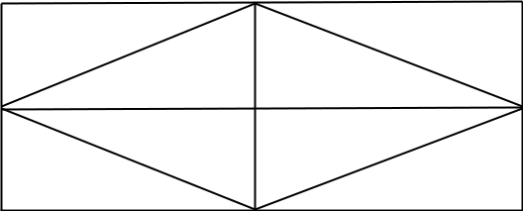

Solution:

First of all we list edges in ascending order.

(e,d)=1

(h,i)=2

(a,f)=2

(b,f)=3

(e,h)=3

(c,d)=3

(b,c)=4

(d,i)=4

(d,h)=4

(g,h)=4

(b,e)=5

(a,b)=5

(f,g)=6

(b,d)=6

(e,f)=7

(f,h)=8

Step1 : take an edge with minimum weight

e 1 d

step 2: adding (h,i) and (a,f) having weight 2 on T.

e |  | 1 | d
h |  | 2 |  | i | a |  | 2 | f

step 3 : adding (b,f),(e,h),(c,d) having weight 3 on T.

Page | 6
Course ID : BIT 114 |  |  |  |  |  |  | Course Name: Discrete Math
 |  |  |  |  |  |  | Program: BIT Fall 2019
 |  |  |  |  |  |  | Semester:1Year/1semester
 | e |  | 1 | d | 3 |  |  |  | c |  | b
 |  |  | 3 |  |  |  |  |  |  |  | 3
 |  |  | 2 |  | i |  | a |  | 2 |  | f
 | h |  | 2
 | step 4: adding (b,c),(d,i),(d,h),(g,h) having weight 4 on T.

 | e | 1 | d | 3 c
 | 3
4 | h | 2 |  | i | 4
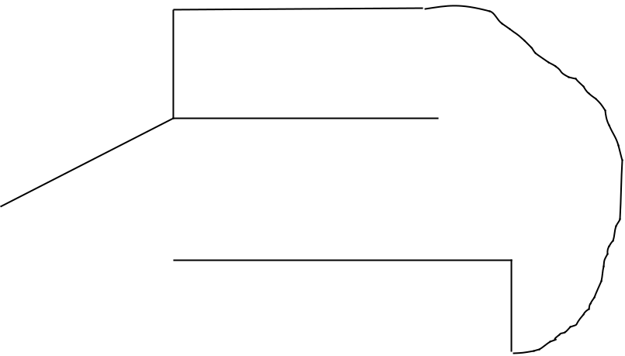

g

a 2 f

3

b

here in step 4 the circuit is formed so they are excluded (d,h),(d,i)

step 5 : adding (b,e),(a,b) having weight 5 on T. here (a,b),(b,e) is excluded because it makes circuit (f,g),(b,d),(e,f),(f,h) are also excluded

Therefore, minimum spanning tree is found to be 22 having weighted.

Page | 7

